**DATA INSIGHTS**

1. No of distinct users/devices : 17419

Query used : “select count(distinct (ai5)) from GgeventLog ”

2. No of distinct SDK versions : 7

Query used : “select count(distinct (sdkv)) from GgeventLog”

3. No of distinct game_id : 20

Query used : “select count(distinct (game_id)) from GgeventLog”

--------------------------------------------------------------------------------------------------

**Missing Values Check**

1. No of missing values in ai5 column : 0

Query used : “select count(*) from GgeventLog where ai5 is null “

2. No of missing values in sdkv column : 0

Query used : “select count(*) from GgeventLog where sdkv is null “

3. No of missing values in event column : 0

Query used : “select count(*) from GgeventLog where event

is null “

4. No of missing values in game_id column : 0

Query used : “select count(*) from GgeventLog where game_id is null “

5. No of missing values in ts column : 0

Query used : “select count(*) from GgeventLog where ts is null “

Game wise Distribution

This will tell us the distribution of recorded events of each Game id in the input file.

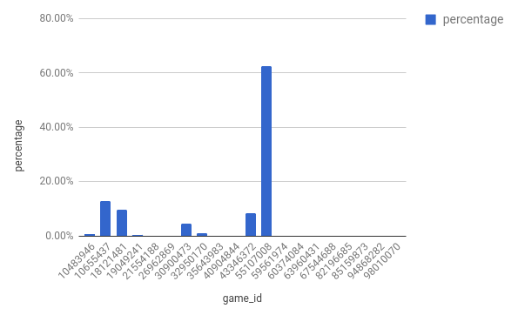

Above chart shows that game id 55107008 was the most no of times played game in ggevent.log file (shared by Greedy Game) .

The second Game with most no of recorded events was 10655437

User Session Insights

1. No of Distinct devices/users: 17419
2. Total session Insight

|  |  |
| --- | --- |
| Total sessions | Count |
| Maximum | 17 |
| Minimum | 0 |
| Mean | 1.40 |
| no of users with 0 total sessions | 666 |

3. Valid Session Insights

|  |  |
| --- | --- |
| valid_sessions | count |
| Maximum | 10 |
| Minimum | 0 |
| Mean | 1.007 |
|  |  |
| no of users with 0 Valid sessions | 4084 |

4. Average Session time (in seconds) Insights (valid only)

|  |  |
| --- | --- |
| average_session_time_inseconds | count |
| Maximum | 3532 |
| Minimum | 0 |
| Mean | 406.0 |